Test Case No. 1

Date Processed: 26 January 2019

Test Case Scenario:

Ensure that Employee record / registration won’t go through or will not get posted to the company’s database if data is not complete.

Action:

The developers of this program aims to ensure that all necessary information will be logged and will be saved onto the company’s database accordingly (for safe keeping purposes).That is why certain validation were added to the “Employee registration form” to ensure that all required and necessary data’s or information will be captured accordingly. Also please take note that employee data is required in order for an administrator to create an access for certain users (applicable for administrator access, Dispatch and receiving access).

Expected Result:

The developers are expecting that the system will not allow the form to go through or will not go straight to the set database if some fields are empty.

Screenshot:

Employee Registration if fields are not complete

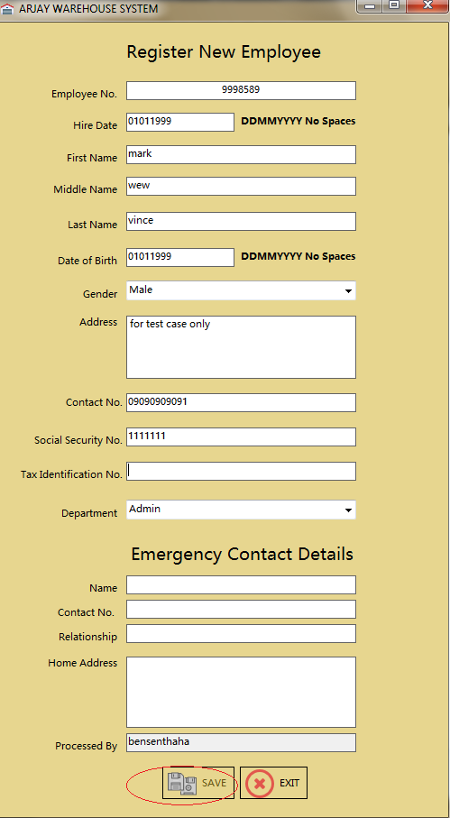

Employee Registration form once all field is complete

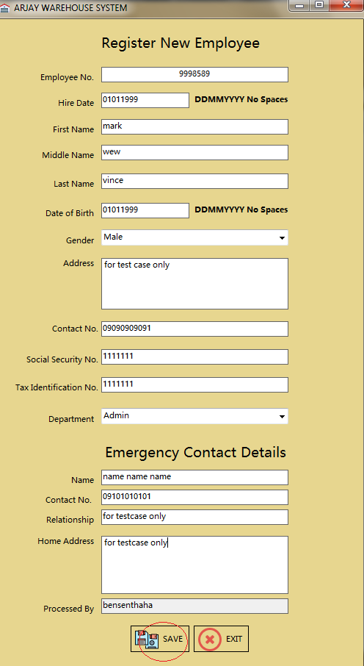

Employee Registration form once save button is click

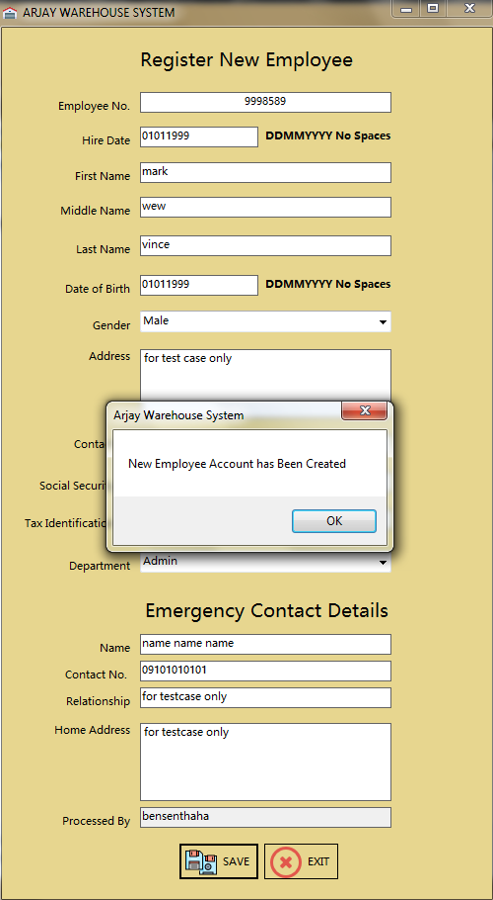

Snippet from the database



Remarks:

The developers of this program was able to execute the validation process / method accordingly and by using the validation that the programmers set onto this form the developers can ensure and 100 percent confident that all data being stored onto the company’s database is concise and complete.

Actual Output:

The developers of this application did passed this test.

Test Case No. 2

Date: 26 January 2019

Test Case Scenario:

Ensure that all access will be monitored and will be log accordingly.

Action:

The Developers of this application did added a feature on to the logon form applicable for all three users Administrator, Dispatch and Receiving as part of security validation and its audit. The developers of this program will now check if those validations will work accordingly.

Expected Output:

The developers of this program is expecting that the username, IP address, computer name, access type, Output if its success or failed and most important of all, the time and date of access. The developers are confident that those information will be captured.

Screenshot: 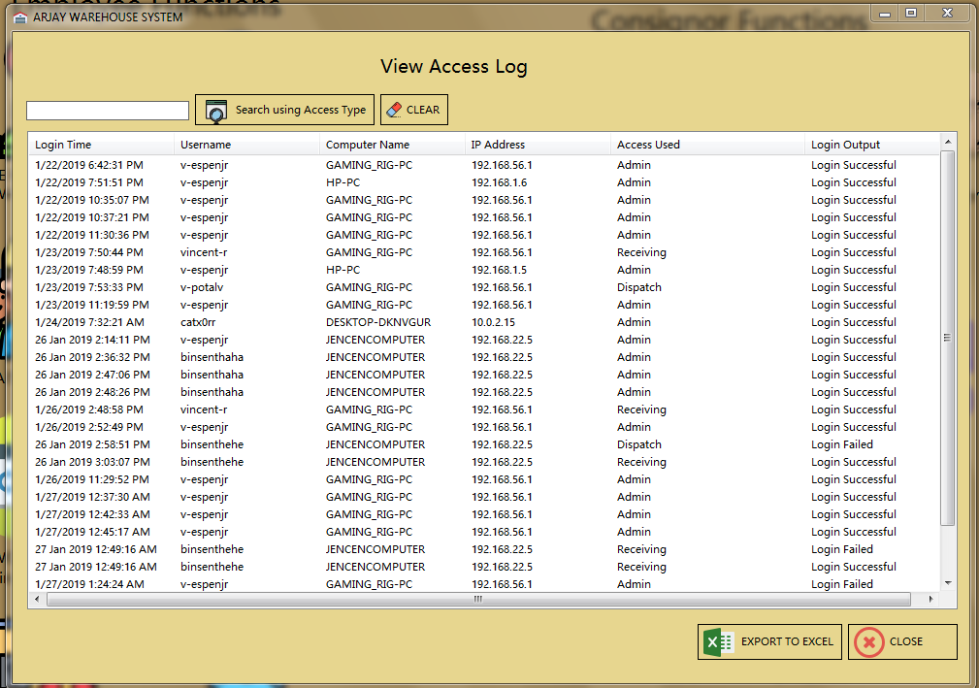

Remarks:

Based on the screenshot listed above the developers of this application were able to get the result that they wanted, it is a success as far as security and audit is all concern. The log in form was able to capture the following username, IP address, computer name, access type, Output if its success or failed and most importantly the time and date.

Actual Output:

The developers of this program did passed this test.

Test Case No. 3

Date: 26 January 2019

Test Case Scenario:

Ensure that no one can login if the username and password is empty or blank.

Action:

The developers of this application did set up a condition via login form that if the username and password field is empty the button will be set to inactive state. Hence it will be active if it is not empty.

Expected Result:

The developers are expecting that the login button will be set to inactive state if both username and password is empty.

Screenshot:

With Empty Field it shows that the login button still in inactive state.

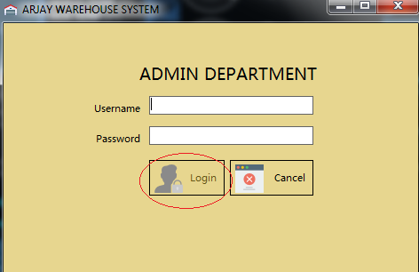

Username is filed up but Password filed is still empty.

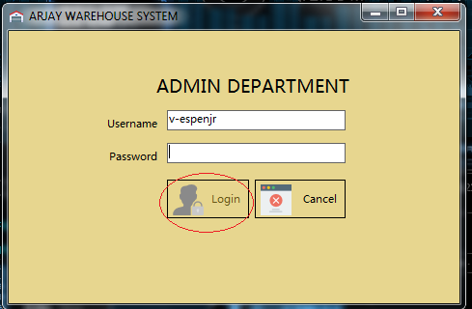

If username and password filed is not empty.

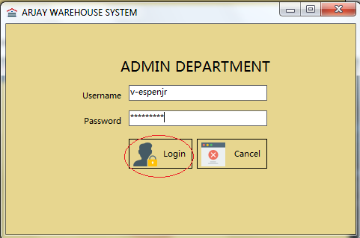

Remarks:

The developers of this application was able to execute the validation accordingly. The team was able to ensure that no one can access this application using an empty information.

Actual Output:

The developers of this program did passed this test.

Test Case No. 4

Date: 26 January 2019

Test Case Scenario:

Ensure that the system will not allow a user to login using an incorrect credentials.

Action:

The developers of this program set a rule that if the username and password listed didn’t match the data listed via database the system will prompt them an error stating about the incorrect credentials.

Expected Result:

The developers are expecting that error message will show up if credentials entered is incorrect. The developers of this program will going to recreate this process by just entering random username and password.

Screenshot:

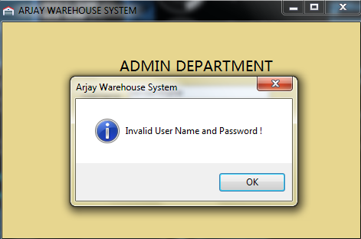

Remarks:

The developers of this application was able to get the expected output and this is applicable for all three user the Administrator, Dispatch and Receiving.

Actual Output:

The developers of this program did passed this test.

Test Case No. 5

Date: 26 January 2019

Test Case Scenario:

Ensure that the system will not going to allow the Administrator to create an empty account or Access.

Action:

The developers of this program did ensure that create account function is well validated by ensuring that the administrator will not or cannot create an access if necessary information are not present. This validation is present for all three user types the Receiving, Dispatch and Administrator.

Expected Result:

The developers are expecting that the create button will not be active during form load event. The developers wanted to ensure that the database will intact and information are all accurate and concise.

Screenshot:

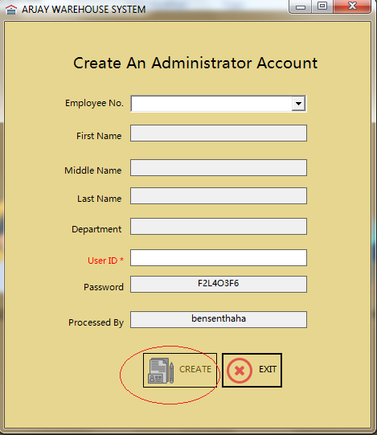

Remarks:

The developers of this program was able to get the expected result. The validation that the developers set during form load did work right away and by using this simple validation process the team is positive that mistakes and empty data in the database will be and can be reduced or voided completely. And this process or validation is applicable for all three access / user type namely Receiving, Dispatch and Administrator.

Actual Output:

The developers of this program did passed this test.

Test Case No. 6

Date: 26 January 2019

Test Case Scenario:

The developers of this application want to ensure that no account or access can be created without a username or user Id.

Action:

The developers of this program did set another validation wherein the create button will remain disable if no username or user id is issued. Using this test the team will be able to determine if this function will work or not.

Expected Result:

The developers are expecting that the create button will remain disable or inactive up until the administrator issued a username or ID to the user.

Screenshot:

No Username or ID yet 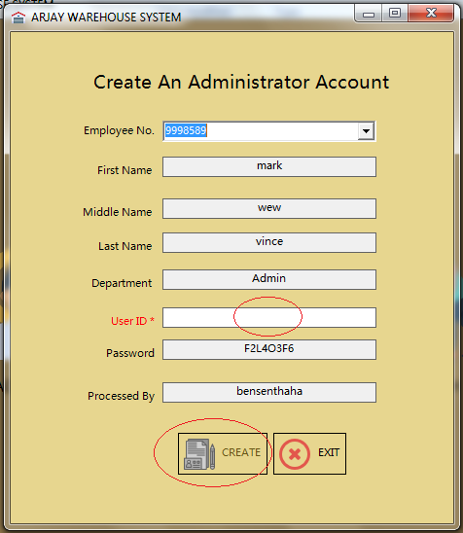

With Username or ID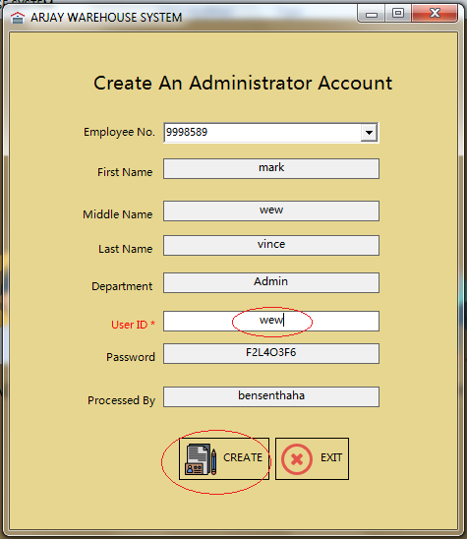

Message Prompt for successful access creation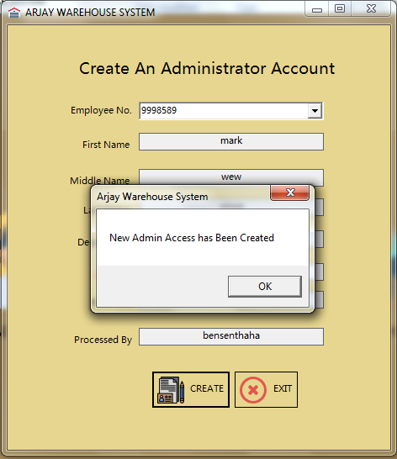

Remarks:

The developers of this program was able to get the result that they are wanting to get. Using this simple validation process Account Administrator can ensure that all the data listed via the company’s database are all accurate and complete. And this validation are all present in all three access levels the Receiving, Dispatch and Administrator level.

Actual Output:

The team was able to pass this validation process and the developers passed this test.

Test Case No. 7

Date: 26 January 2019

Test Case Scenario:

Ensure that the validation for termination form is placed accordingly and empty data will not go through to avoid future database problem.

Action:

Same with Access Creation form the developers of this program did set certain validation to avoid empty data to be executed. The team wanted to ensure that this function will work accordingly to avoid future problems.

Expected Result:

The developers are expecting that the system will not allow the administrator to execute any action if the form is empty.

Screenshot:

With Empty data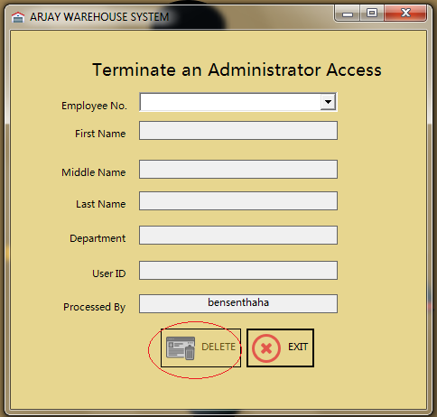

Form with Data

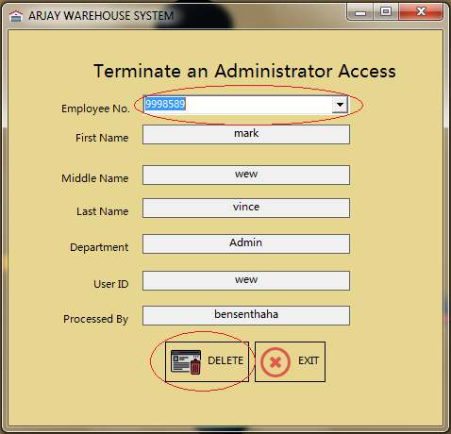

Message and output once executed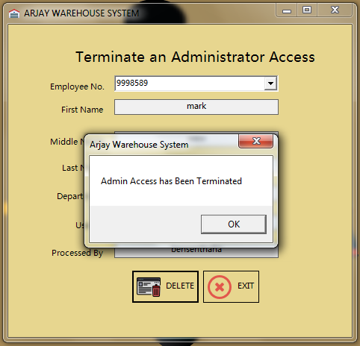

Remarks:

The developers of this program was able to get the result that they are wanting to obtain. Using the simple validation processed that they embedded onto this form user can avoid accidental entry or changes especially if data is empty.

Actual Output:

The team was able to pass this validation test and this validation process are all present for all three access levels namely Receiving, Dispatch and Administrator level.

Test Case No. 8

Date Processed: 26 January 2019

Test Case Scenario:

Ensure that system will not going to allow any password reset entry or changes especially if the password set is already present via database.

Action:

The developers of this program knew that data overwrite is possible especially if the dataset is similar or identical to a data that is already present or existing inside the database. That is why a validation was added wherein the system will going to scan the database first to search for a similar data and forbid the user if that data already exist. In this test a self-help password reset will be executed and the developer will going to use a password that already exist via database.

Expected Result:

The team is expecting that the program will not going to allow or execute the changes and expecting that an error message will prompt.

Screenshot:

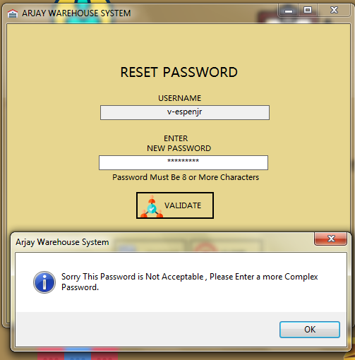

Remarks:

The developers of this program was successful in doing this test. The validation and code that the team embedded onto this application did work accordingly. And by having this process the team is at ease that data overwrite will be eliminated most especially when it comes to the users’ password. This test is applicable for all password reset process (Self-help process and even in admin function).

Actual Output:

The developers of this application did pass this test accordingly.

Test Case No. 9

Date Processed: 26 January 2019

Test Case Scenario:

Ensure that all access and account related changes being made or performed by an administrator will be logged accordingly in compliance to security and audit process.

Action:

The developers of this program was completely aware that sometimes unauthorized changes are being made to either an account, access, etc. and this changes can be production impacting at times. That is why the developers of this program did ensure that every changes that will be made by an administrator to a users’ profile will be logged accordingly in case audit is needed or required. This demonstration will be executed using the form called “View Access Modification by Admin” present via Admin panel.

Expected Result:

The developers of this application are expecting that changes/modification and actions performed by an administrator will be logged accordingly.

Screenshot:

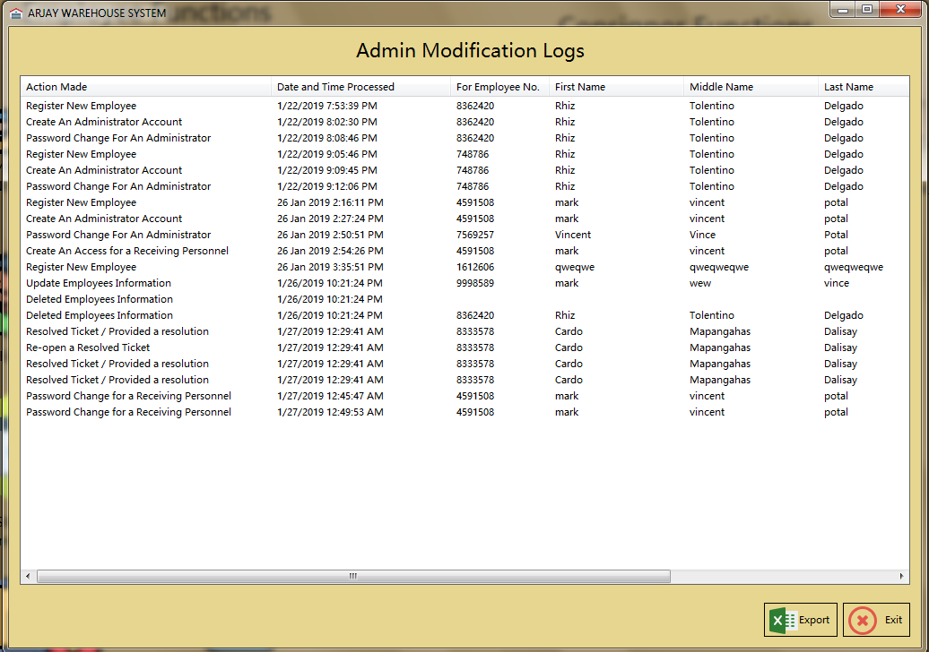

Remarks:

The developers of this application was able to get the result that they are wanting to get. Using this form or feature the administrator can determine the changes made , affected user and role , time and date of the changes and of course username or ID of the user who performed the changes.

Actual Output:

The developers of this program did passed this test.

<wala pa ito kulang pa >

Test Case No. 10

Date Processed: 26 January 2019

Test Case Scenario:

Ensure that the network connectivity is present, applicable and working.

Action:

Since the nature of this program is web based (as far as connectivity is concern) the developers knew that network capability is a must. That is one of the reasons why the developers of this application did a lot of research on how online database hosting works, aside from the clients requirements and request as well. Using this test case the developers will demonstrate that remote access is possible and the team can connect to each other using different IP addresses, different login information and access type while working away from each other.

Expected Result:

The team is expecting that they can all connect to each other using the application that they have developed which is the “Arjay Warehouse System” with the help of the online database that the team configured and set specifically for this project.

Screenshot:

Remarks:

Actual Output:

Test Case No. 11

Date Processed: 26 January 2019

Test Case Scenario:

Action:

Expected Result:

Screenshot:

Remarks:

Actual Output:

Test Case No. 1

Date Processed: 26 January 2019

Test Case Scenario:

Action:

Expected Result:

Screenshot:

Remarks:

Actual Output: